WEEK 11 PRACTICAL WORKSHEET

**NAME: An Truong CLASS DAY & TIME:**

Note: While following the steps in Week 11 Practical instruction PDF, type your answers to the questions in this worksheet (replace the blank lines with your answers). After finish, submit the worksheet (together with the .pkt file created for Parts 2 & 3 of the lab) by following the requirement given on page 1 of Week 11 Practical instruction PDF.

**PART 1 Design a Network Subnetting Scheme**

* 1. Create a subnetting scheme that meets the required number of subnets and required number of host addresses.

Answer the following questions to help create a subnetting scheme that meets the stated network requirements:

**1)** 25

**2)** The requirements stated above specify 2 company networks + 2 loopback virtual networks + 2 additional networks for future expansion. = minimum 6 networks

**3)** 11111111.11111111.11111111.00000000

**4) a.** network portion **b.** host portion

**5)** Read the information in 5) of Step 1 in the practical pdf to understand what you need to do to answer the following questions

(/25) 11111111.11111111.11111111.**1**0000000

Dotted decimal subnet mask equivalent: 255.255.255.128

Number of subnet bits (i.e. bits borrowed)? 1 Number of subnets created? 2

Number of hosts in each subnet? 126

(/26) 11111111.11111111.11111111.**11**000000

Dotted decimal subnet mask equivalent: 255.255.255.192

Number of subnet bits (i.e. bits borrowed)? 2 Number of subnets created? 4

Number of hosts in each subnet? 62

(/27) 11111111.11111111.11111111.**111**00000

Dotted decimal subnet mask equivalent: 255.255.255.224

Number of subnet bits (i.e. bits borrowed)? 3 Number of subnets created? 8

Number of hosts in each subnet? 30

(/28) 11111111.11111111.11111111.**1111**0000

Dotted decimal subnet mask equivalent: 255.255.255.240

Number of subnet bits (i.e. bits borrowed)? 4 Number of subnets created? 16

Number of hosts in each subnet? 14

(/29) 11111111.11111111.11111111.**11111**000

Dotted decimal subnet mask equivalent: 255.255.255.248

Number of subnet bits (i.e. bits borrowed)? 5 Number of subnets created? 32

Number of hosts in each subnet? 6

(/30) 11111111.11111111.11111111.**111111**00

Dotted decimal subnet mask equivalent: 255.255.255.252

Number of subnet bits (i.e. bits borrowed)? 6 Number of subnets created? 64

Number of hosts in each subnet? 2

**6)** /25, /26, /27

**7)** /27, /28, /29, /30

**8)** /27

**Note** that when equal sized subnets are created from a base network, the prefix and subnet mask will be the same for each subnet created.

|  |  |  |
| --- | --- | --- |
| Subnet Address  (i.e. network address of each subnet) | Prefix  ((slash notation /xx, where xx is the number of network bits)) | Subnet Mask  (in dotted decimal format) |
| 192.168.0.0 | /27 | 255.255.255.224 |
| 192.168.0.32 | /27 | 255.255.255.224 |
| 192.168.0.64 | /27 | 255.255.255.224 |
| 192.168.0.96 | /27 | 255.255.255.224 |
| 192.168.0.128 | /27 | 255.255.255.224 |
| 192.168.0.160 | /27 | 255.255.255.224 |
| 192.168.0.192 | /27 | 255.255.255.224 |
| 192.168.0.224 | /27 | 255.255.255.224 |

* 1. Complete the addressing table and the diagram showing where the host IP addresses will be applied.

**1)** Based on the subnetting scheme derived in the previous step, complete the addressing table below by assigning the subnets and addresses as instructed

Read the information in Step 2 in the practical pdf to understand what you need to do fill in this table

|  |  |  |  |  |
| --- | --- | --- | --- | --- |
| Device | Interface | IP Address | Subnet Mask | Default Gateway |
| R1 | G0/0 | 192.168.0.1 | 255.255.255.224 | N/A |
|  | G0/1 | 192.168.0.33 | 255.255.255.224 | N/A |
|  | Lo0 | 192.168.0.65 | 255.255.255.224 | N/A |
|  | Lo1 | 192.168.0.97 | 255.255.255.224 | N/A |
| S1 | VLAN 1 | 192.168.0.30 | 255.255.255.224 | 192.168.0.1 |
| PC-A | NIC | 192.168.0.2 | 255.255.255.224 | 192.168.0.1 |
| PC-B | NIC | 192.168.0.34 | 255.255.255.224 | 192.168.0.33 |

1. Fill in the IP addresses and subnet masks in slash format for each device, in the text boxes provided.

192.168.0.97/27

192.168.0.65/27

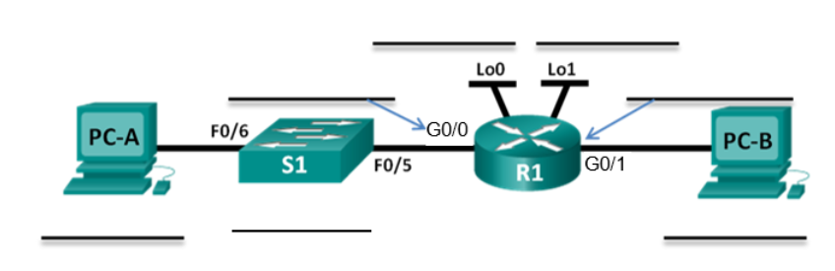

192.168.0.34/27

192.168.0.30/27

192.168.0.2/27

192.168.0.1/27

192.168.0.33/27

/27

**Now inform your tutor that you have completed Part 1.** AfterPart 1 is checked, follow the steps in this practical instruction PDF to complete **PART 2** & **PART 3** in Packet Tracer, then submit this worksheet and the .pkt file before the deadline.